Automation Test Preconditions:

Step 1 : Before you Run the test “ValidNewuser_SuccessfulRegistration_MessageCheck”

First set the value in the Subroutine folder “Sub\Fill Registration Form” - Line 2 value to something unique so that the registration does not fail on uniqueness test.

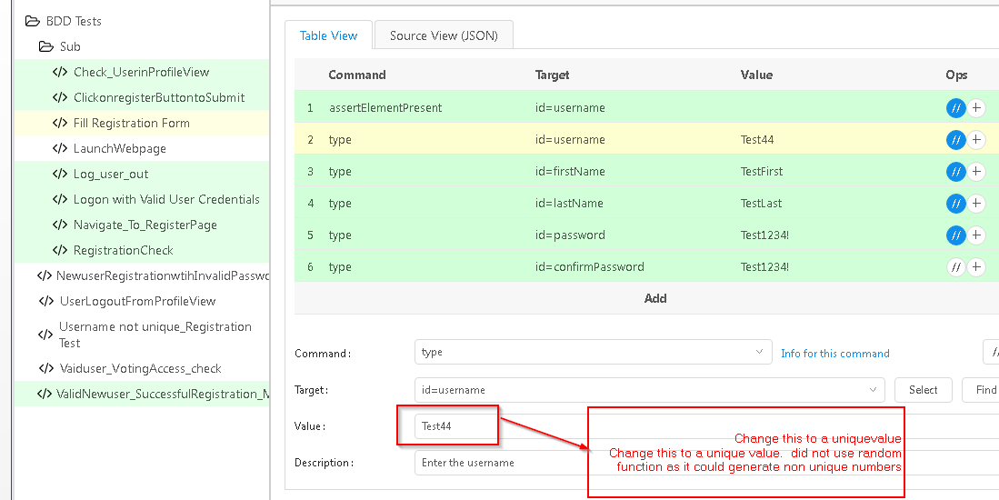

Save the change and run the test “ValidNewuser_SuccessfulRegistration_MessageCheck”